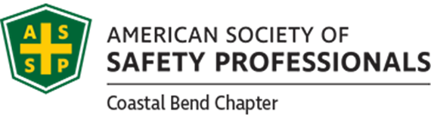
American Society of Safety Professionals, Coastal Bend Chapter
One Day Professional Development Conference 1/18/2019
Scholarship & Educational Opportunities Fundraiser

Each year the Coastal bend Chapter of the American Society of Safety Professionals (ASSP) provides financial aid to students attending college in pursuit of a career in the safety, health or environmental professions. This financial assistance is made available through the ASSP Coastal Bend Scholarship Fund. This fund also provides assistance to deserving students and professionals as they pursue professional development opportunities. We have been fortunate over the years as our society has been supported in this effort by many organizations. Without their dedication and effort this vital program would not be possible.
In continuing with the scholarship program this year, we have recognized that college tuition and professional development fees have increased significantly in recent years. As such, we are striving to help meet the demands placed of deserving students and professionals by dedicating more energy to increase the scholarship funding and/or the number of opportunities available.
We are in the process of applying for CEU credits for this professional Development Conference.

For more information on the scholarship fundraiser, you may contact us at the following:
Smokey Stevens, Valero Corpus Christi 361-299-8917 or smokey.stevens@valero.com
Missy Socha, Vallen Safety 361-658-3369 or missy.socha@vallen.com

